P R E S S R E L E A S E

Updates available for certification tools and GSD Checker

Karlsruhe, Germany – September 27, 2021: The implementation of future-proof technology hinges on the integration of concepts – and the specifications based on them – into different devices from many manufacturers. This enables users to meet continually increasing requirements on efficiency and cost effectiveness, as well as to overcome new digitization challenges in systems and machines. For this, in turn, to work simply and smoothly, consistent quality assurance of the devices through comprehensive certification is required.

This is why the PI (PROFIBUS & PROFINET International) Community is investing serious commitment and lots of resources into the further development of testing tools for PROFINET certification – tools which are now available in new current versions of the test bundles.

With the new PROFINET test bundle, another milestone was reached on the road to complete test automation. This includes, among other things, the automation of controller test cases and evaluation of MRP test sequences. As part of regular maintenance, the primary task was to convert the tools to the current version of Windows 10, i.e. 20H2.

With this test bundle, the PI test labs carry out uniform tests across the globe. As this bundle is available to every PI member, it's possible to prepare for this official certification in an ideal way. Using the open interface, the testing tools and the associated test cases – or custom-defined cases – can be integrated as an additional quality-assurance measure into the agile development process of manufacturers.

PI makes trial bundles available early on for the purpose of getting started with new topics. These trial bundles focus on one technological aspect or feature and provide correspondingly targeted tools and test cases for it. This enables manufacturers to test the initial functions of their products in development and also gives the PI test development team early feedback on the new testing system.

As such, a TSN trial test bundle which tests synchronization and RSI functions is now available. Test cases for PA Profile V4, such as address mapping, startup, physical blocks and FlowTB, are run using individual PA trial test bundles.

The contents of these tools are continually adjusted and expanded through a backlog prioritization process so that the full range of tests can be put to use for certification testing later on following thorough verification. The trial bundles are updated on a quarterly basis and made available for download from the PI website.

A crucial step familiar to every manufacturer is the creation and testing of the device description (GSD). A new version of the GSD Checker is also available here, which incorporates experience from earlier stages and the current function of the GSD specification. In addition to an organized, easy-to-read view of the parameters, an XML editor is included for integrating changes into a GSD at the same time. The integrated checker function checks for correctness and displays any errors found. The new GSD Checker runs without needing to be installed.

These tools enable manufacturers to efficiently develop a PROFINET device and prepare for certification. This gives users a high degree of interoperability, allowing them to concentrate on implementing their system and machine functions. Experience shows that quality has to be tested. PI provides the tools to get the job done.

***

Graphic:
The new GSD Checker provides an easy-to-read parameter view, an XML editor and checking in a single tool, and example GSDs are included in the package as well.

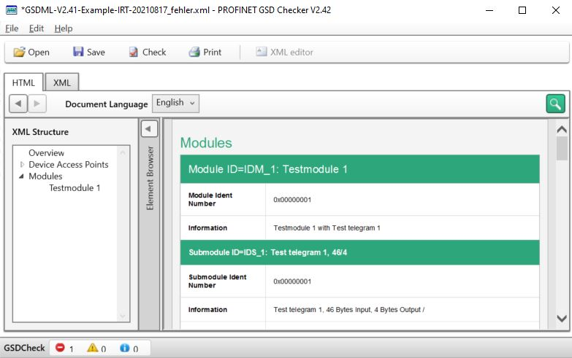
Press contact:
PI (PROFIBUS & PROFINET International)
PROFIBUS Nutzerorganisation e. V.
Barbara Weber

Haid-und-Neu-Str. 7

D-76131 Karlsruhe, Germany
Phone: +49 721 986 197-49
Fax: +49 721 986 197-11
Barbara.Weber@profibus.com
http://www.profibus.com
The text of this press release is available for download at www.profibus.com.

